**Experiment 7**

**DQL commands (college schema)**

**Aim:**

* Display student id and marks from the student table.
* Display faculty id and name from the faculty table.
* Display who got grade A.
* Display whose marks are less than 50.
* Display the female students whose marks are between 50 to 60.
* Delete the failed students.
* Display activity id and name using object.
* Display student id, faculty id using course name condition with object.
* Select department name starting from ‘c’ and faculty name ending with ‘ ’.
* Select activity having characters between ‘ck’.
* Group by faculty id and display.
* Display the students list whose grade is A using having.
* Display the faculty list who are teaching PPS.
* Apply aggregate functions in student marks - max, min, sum, count, avg.

CODE WITH SOLUTIONS:

* Display student no, marks from student table.

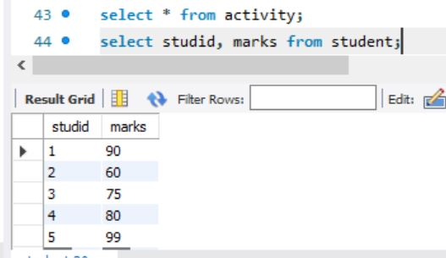

* Display faculty no, name from faculty table

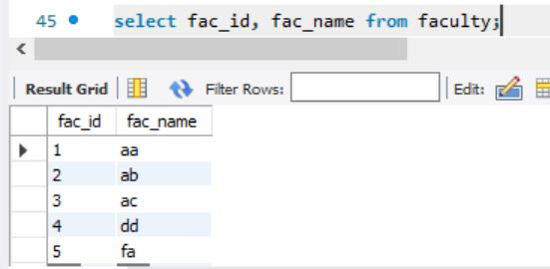

* Display who got grade A

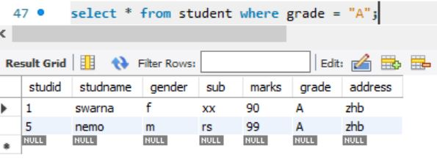

* Display whose mark is less than 50.

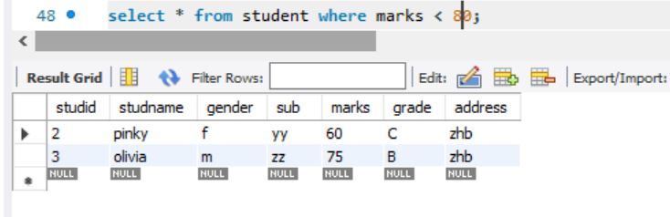

* display the student is and name whose mark is 50 to 60 and female.

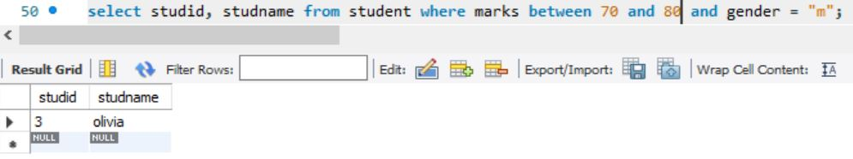

* delete the failure students.

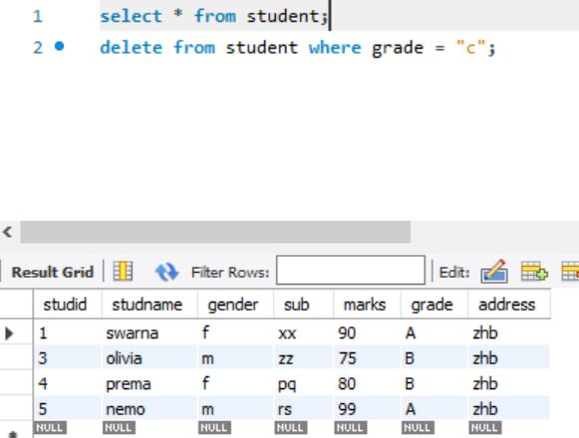

* display activity id, name using object.

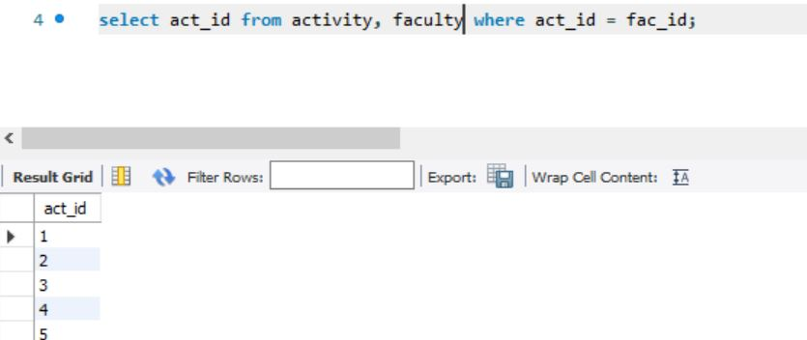

* Select department starts from ‘d’ and faculty name ends with ‘d’

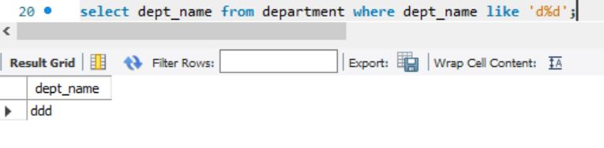

* Select activity having character between ‘hg’

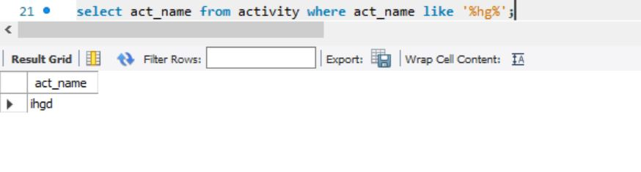

* Group by faculty id and display

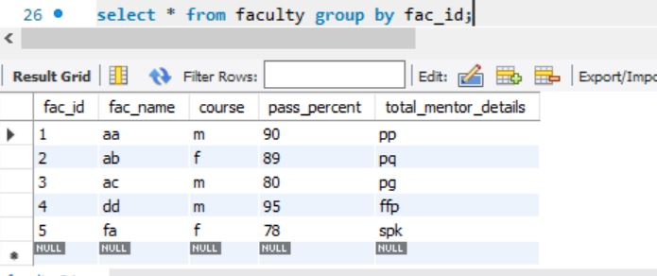

* Display the students list whose grade is A using having

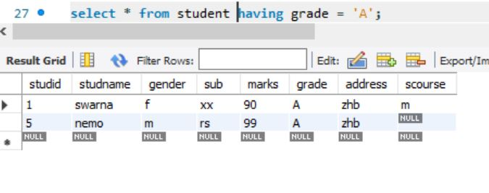

* Display the faculty list who are teaching subject ‘f’

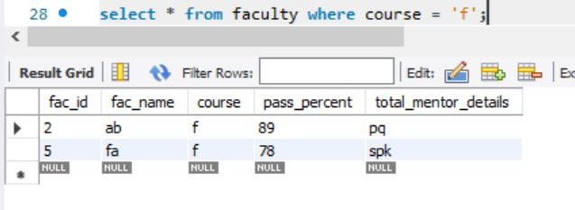

* Apply aggregate functions in students marks – min, max, sum, count, avg.

